FOUNDATION UNIVERSITY ISLAMABAD
SCHOOL OF SCIENCE AND TECHNOLOGY

LAB MANUAL 10

NAME : ALISHBA HAFEEZ
SUBJECT : PF (programming fundamentals)
SECTION : 25(B)
DEPARTMENT : IET
ROLL NO : 056
INSTRUCTOR : Mr. SHAMSHAIR ALI

TASK 10.1:
Explain and show the output of following program. This program takes a string object from the user and calculates the number of vowels, consonants, digits and white spaces.
CODE:
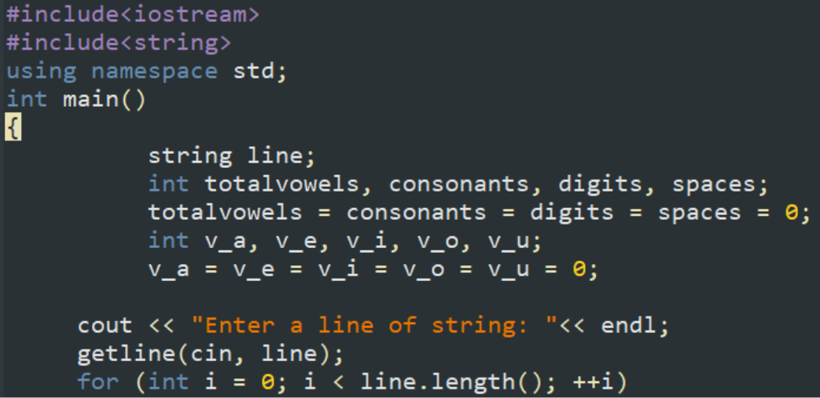
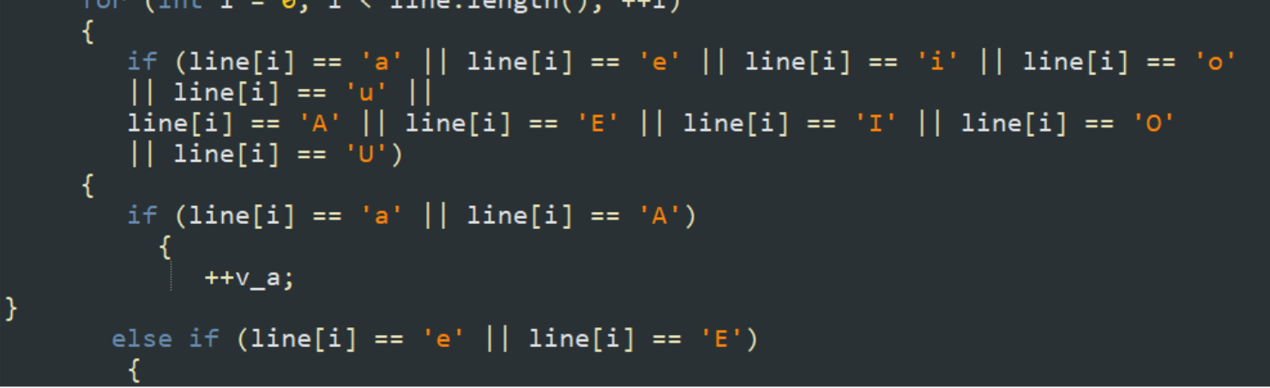
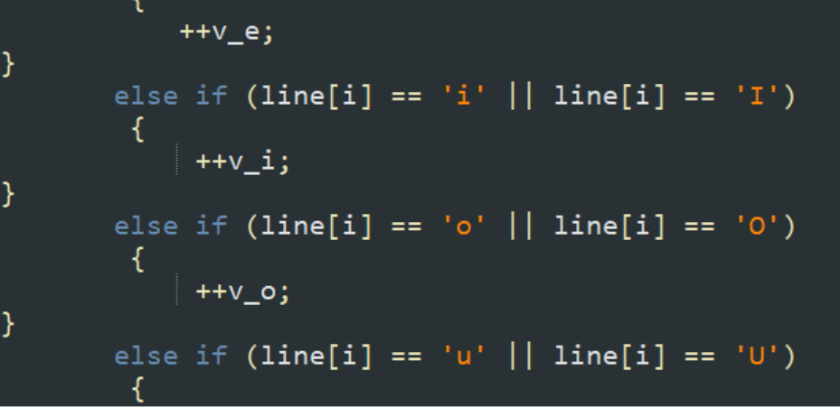
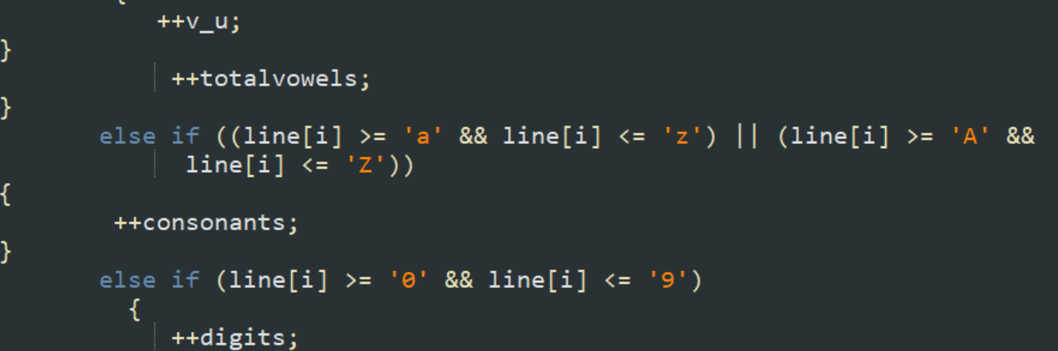
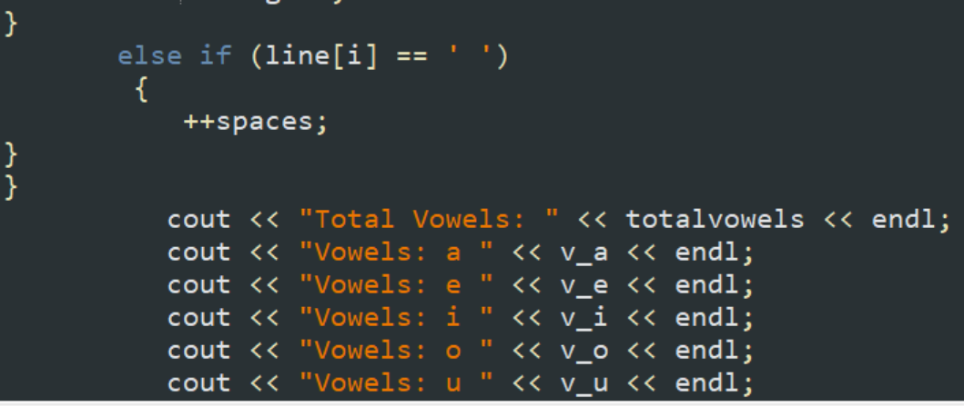
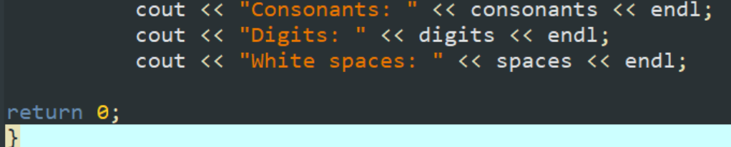

OUTPUT:
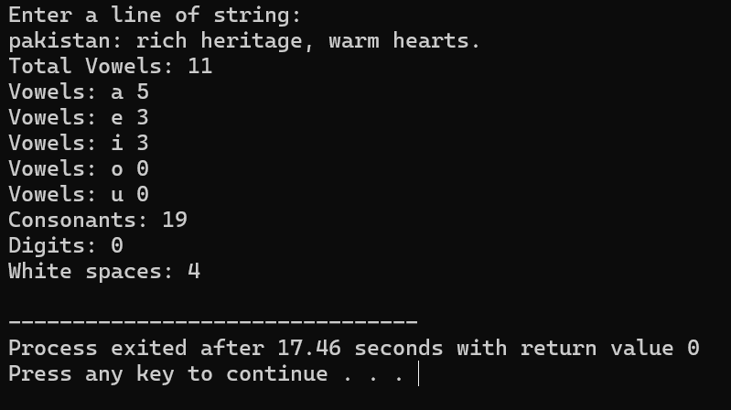

TASK 10.2:
Explain and show the output of following program. This program inserts the characters "**" in the exact middle of a string.
CODE:
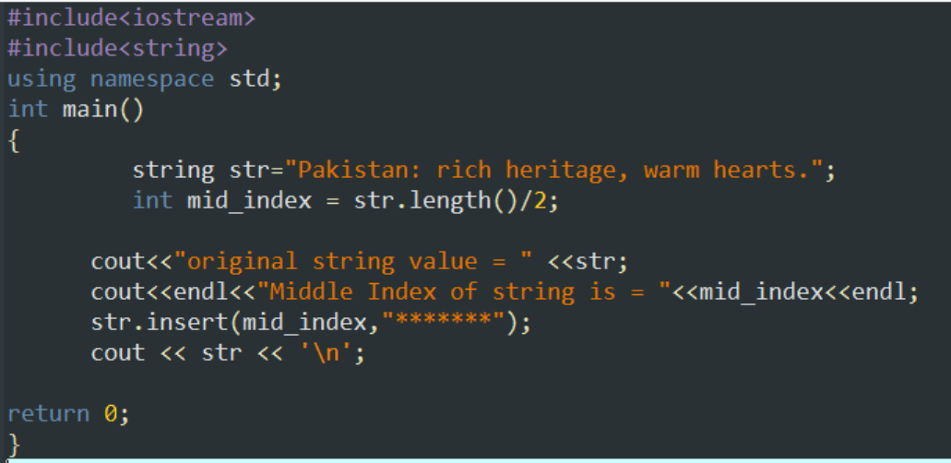

OUTPUT:
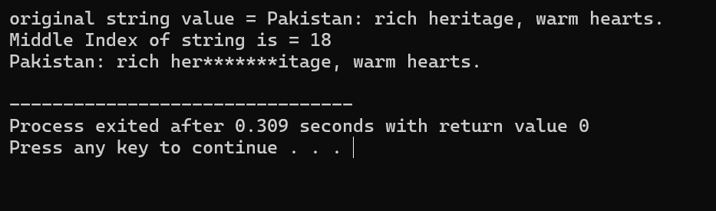
EXERCISE 10.1:
Write a C++ program, that replaces the word "by" with "BY" in a string. Run the code given below for other input strings as well.
HINT: The replace function is used but you have to find an index of ‘b’ in string when the next character should be ‘y’, then you use replace function from the index of b to the next 2 characters with “BY”

CODE:
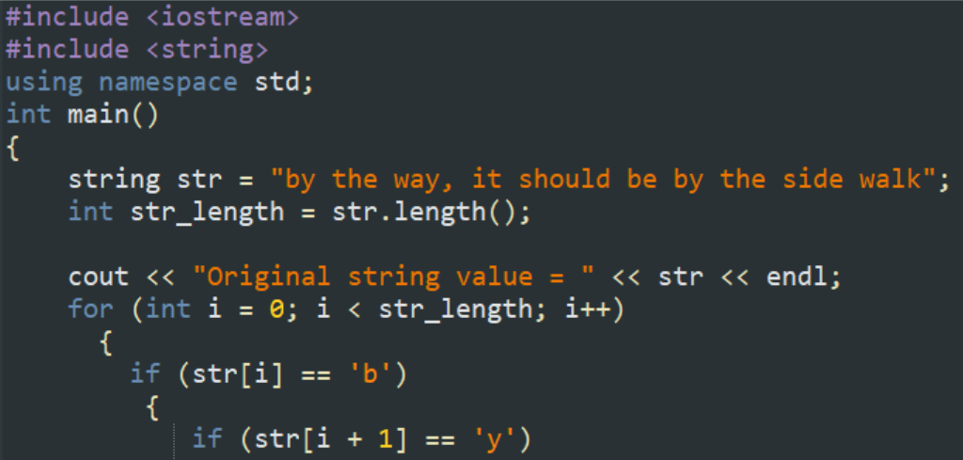
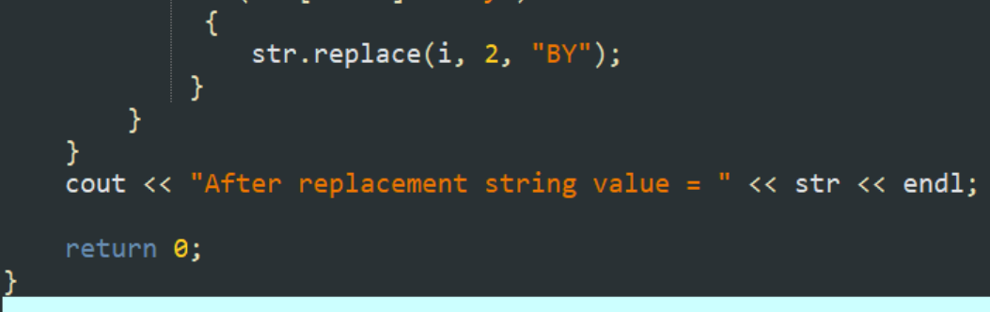

OUTPUT:
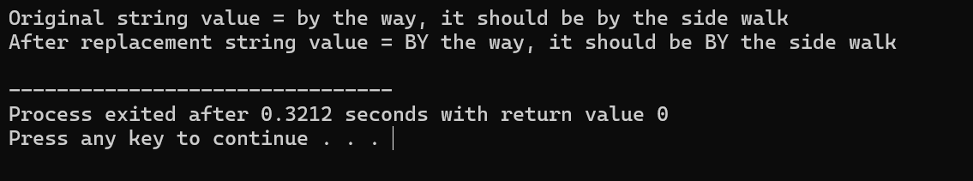
EXERCISE 10.2:
Write a C++ program that inputs a word and checks if it is a palindrome.
HINT: A palindrome is a word that reads the same backwards and forwards. For example, "tree" is not a palindrome, but "noon" is. So, you have to find length of string then first character should be equal to last character and second character should be equal to second last character in string.

CODE:
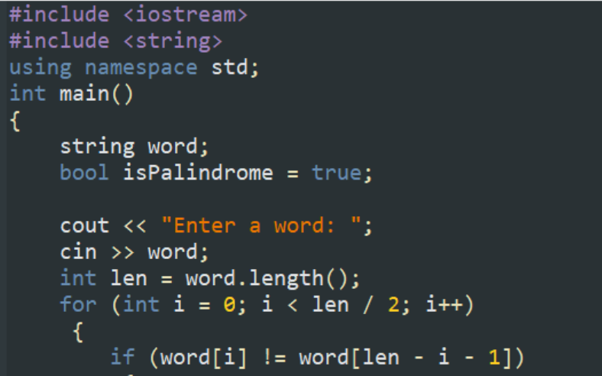
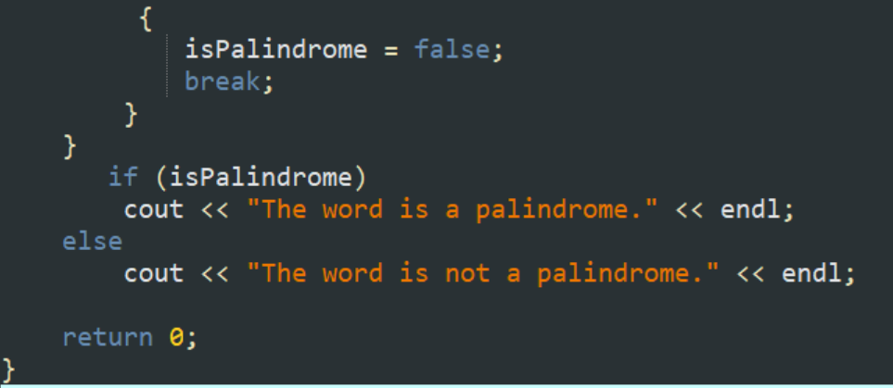

OUTPUT:
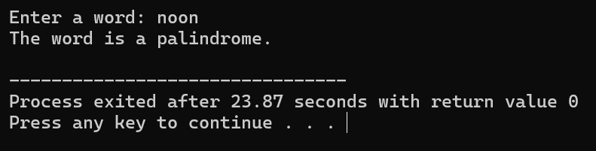
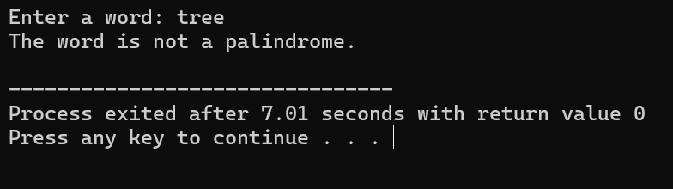

****** THE END ******

